xGCP Guide for CS224n
For your class project, we recommend setting up a GPU instance on GCP (Google Cloud Platform).

BIG REMINDER: Make sure you stop your instances once you are done running!
(We know you won't read until the very bottom once your assignment is running, so we are printing this at the top too since it is super important)

Don't forget to stop your instance when you are done (by clicking on the stop button at the top of the page showing your instances), otherwise you will run out of credits and that will be very sad. :(

If you follow our instructions below correctly, you should be able to restart your instance and the downloaded software will still be available.

Contents
GCP Guide for CS224n
Contents
Colab vs GCP
Create and Configure Your Account
Sign Up GCP for the First Time
Configure Your Project
Claim CS224n GCP Credits
Request an Increase in GPU Quota
Why don't I See Any GPU-related Quota
Set Up Google Cloud VM Image
Customize VM Hardware
Change Configuration on Already Created VM Instances
Configure Networking
Getting a Static IP Address
Access Your Newly Created VM
Install gcloud command-line Tools
Remote Server Development
Using Jupyter Notebook with Google Compute Engine
Verification
Transferring Files From Your Instance To Your Computer
Other Tips
BIG REMINDER: Make sure you stop your instances!

Colab vs GCP
While Colab is good for assignments, and is still a helpful and free tool for experimentation for your project, you will likely need a dedicated GPU instance when you start training on large datasets and collaborating as a team:

- Colab will disconnect after 12 hours or ~30 min of idling (and you will lose your unsaved data). A GCP VM instance will not disconnect until you stop it (or run out of credits).
- A GCP VM instance's disk space allows you to deal with larger datasets. In Colab's case, you will have to save all your data and models to Google Drive.
- Colab does not innately support real-time collaboration.
- You can choose your GPU models and can set >1 GPUs for distributed training on GCP.

Create and Configure Your Account
You should use your personal GMail account for GCP, i.e. NOT SUID@stanford.edu, because Stanford University managed email accounts do not support creating a new project.

For the class project, we offer students $50 GCP coupons for each student to use Google Compute Engine for developing and testing your implementations. When you first sign up on GCP, you will have $300 free credits. You can receive these credits by using an account that has not previously been used for GCP.

This tutorial lists the necessary steps of working on the projects using Google Cloud. We expect this tutorial to take up to an hour. Don't get intimidated by the steps, we tried to make the tutorial detailed so that you are less likely to get stuck on a particular step. Please tag all questions related to Google Cloud with Cloud (GCP) on Ed.

Sign Up GCP for the First Time
You should receive $300 credits from Google when you first sign up with Personal GMail and also UPGRADE it into a full account. Please try to use the resources judiciously.

- Create Google Cloud account by going to the Google Cloud homepage. Click on the blue Get Started for free button. Sign into your Gmail account. Here is an illustrative example.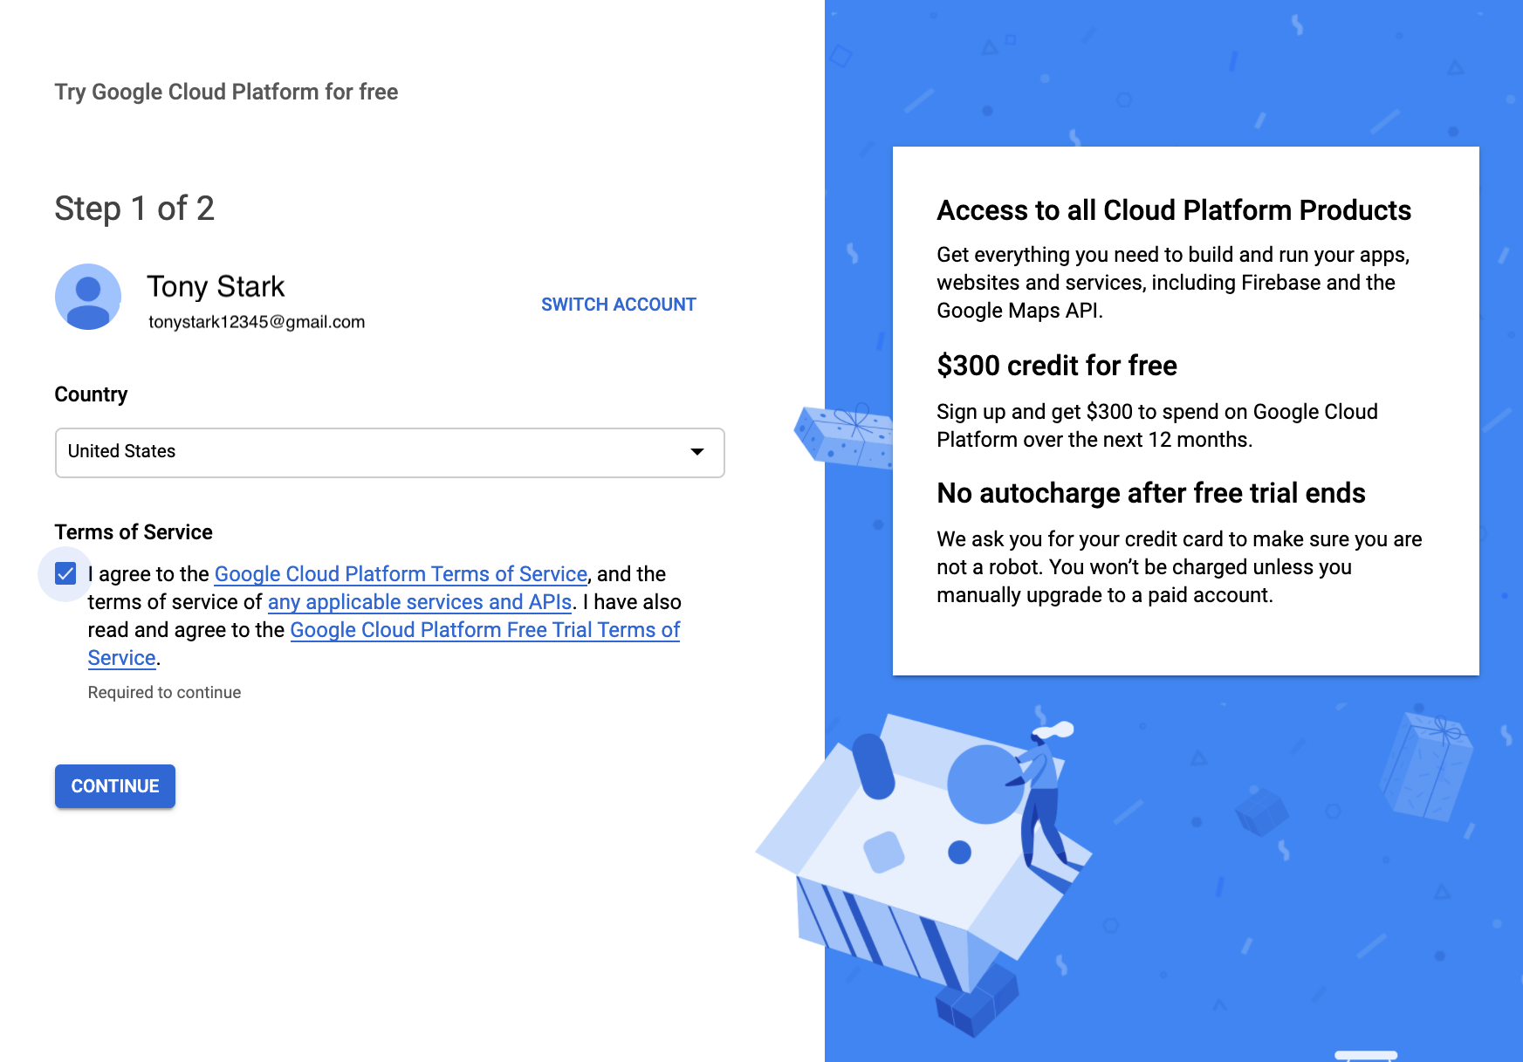
- Choose Account type to be Individual. You will then fill in your name, address and credit card information.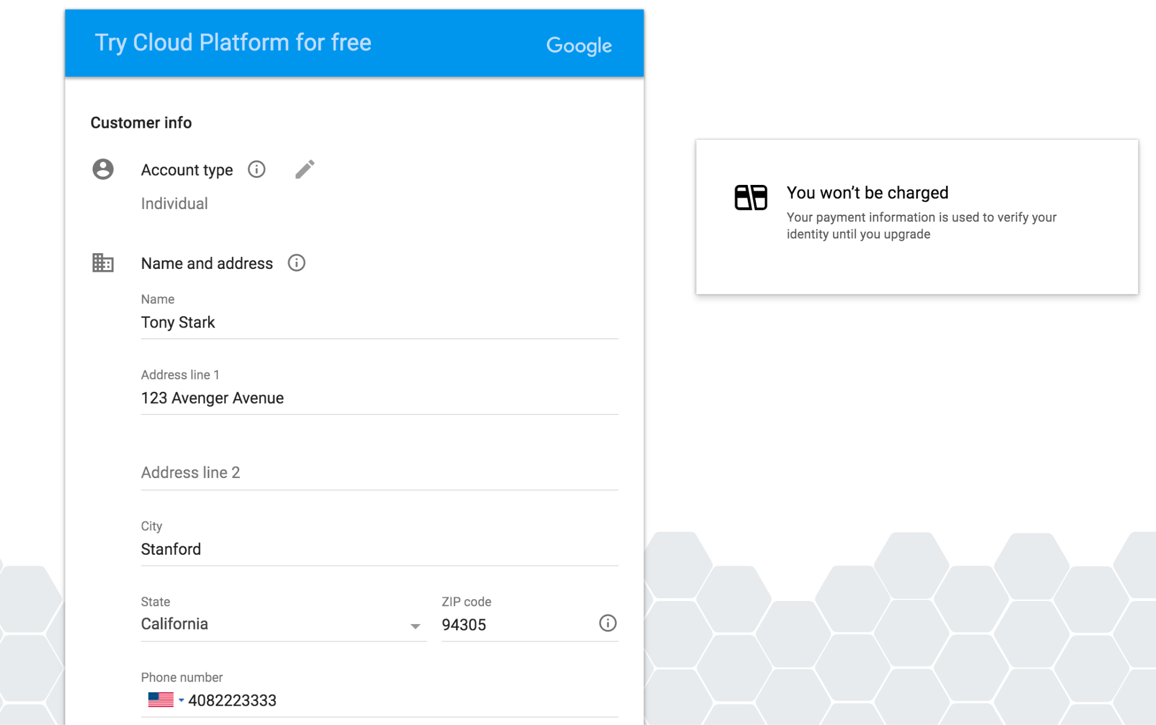
- Click the "Google Cloud Platform" (in red circle), and it will take you to the main project dashboard: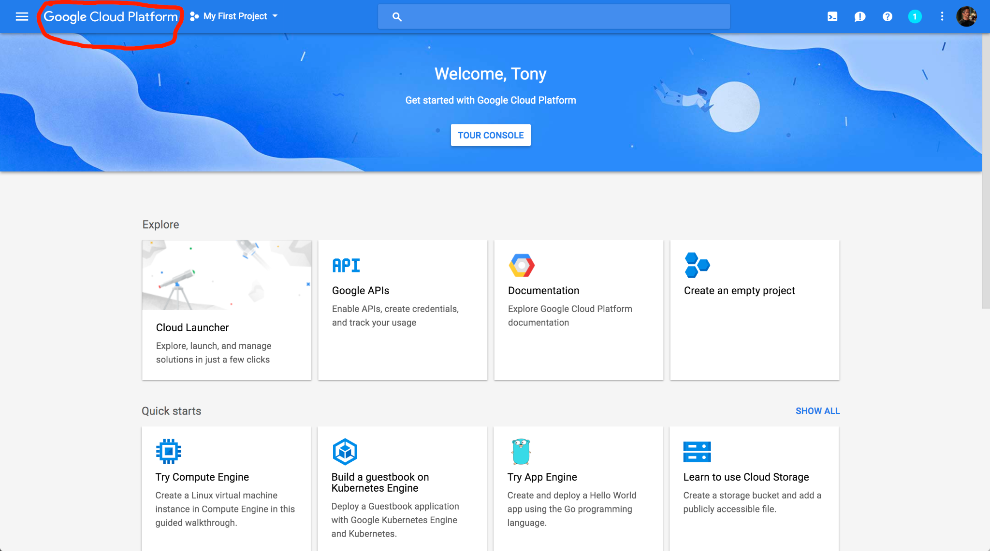

Configure Your Project
- On the main project dashboard, you can change the name of your project by clicking Go to project settings.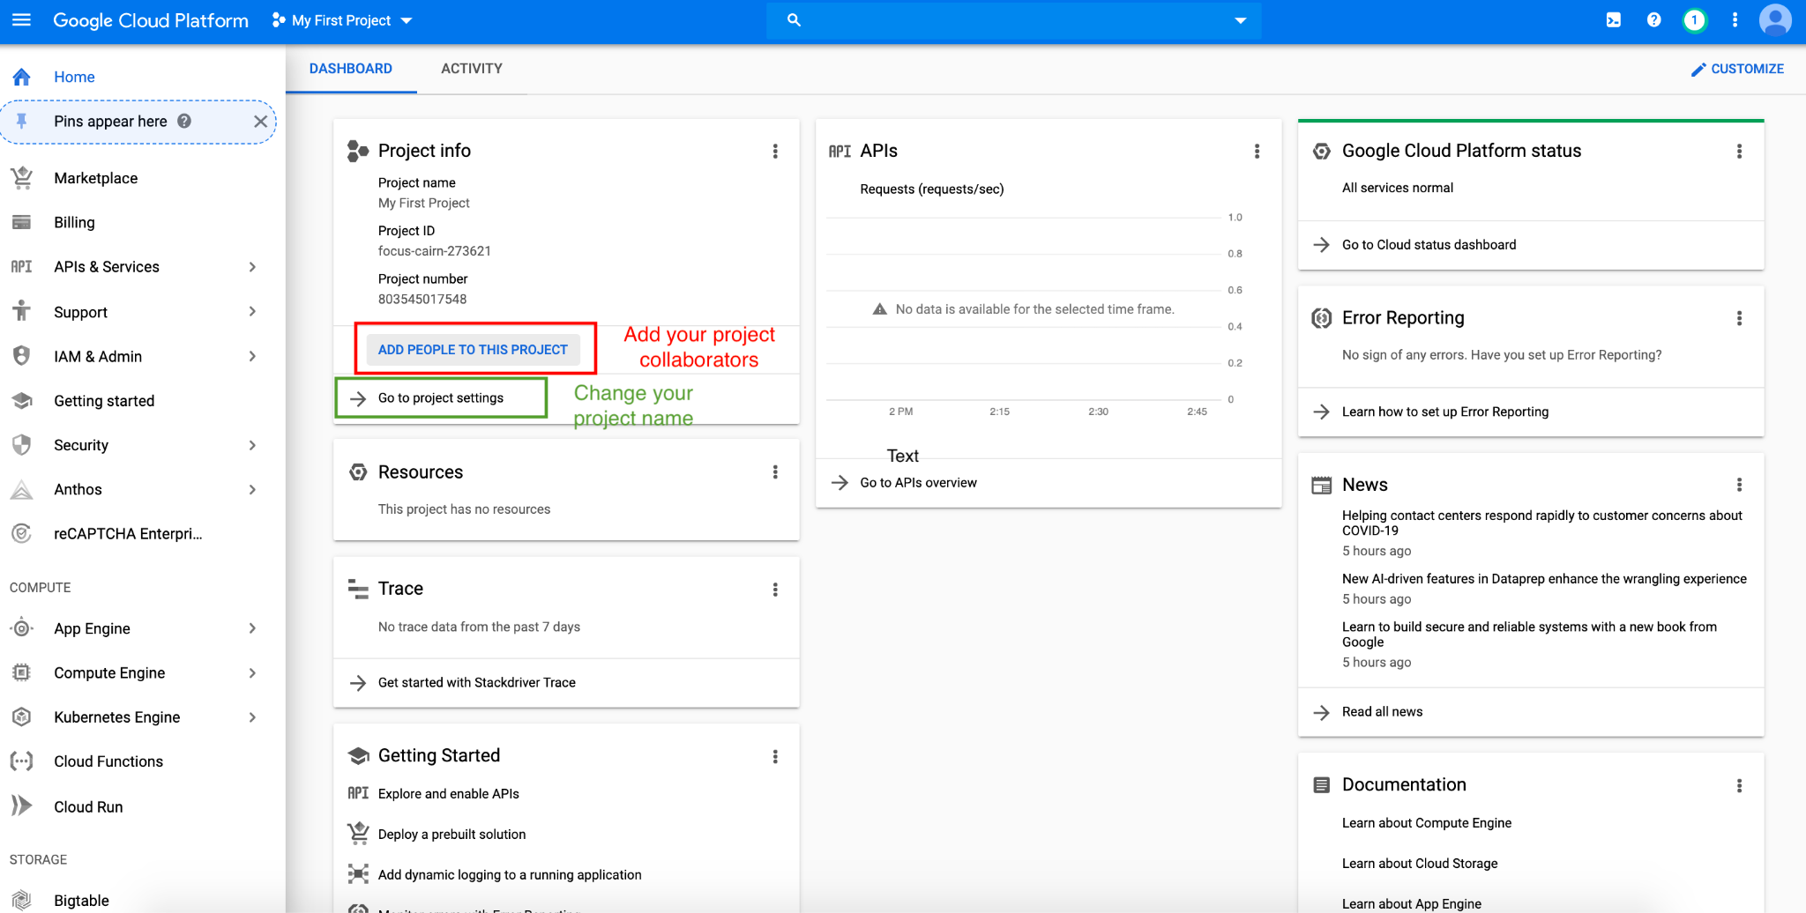
- To add project collaborators, click ADD PEOPLE TO THIS PROJECT. Add their email and make their role owners.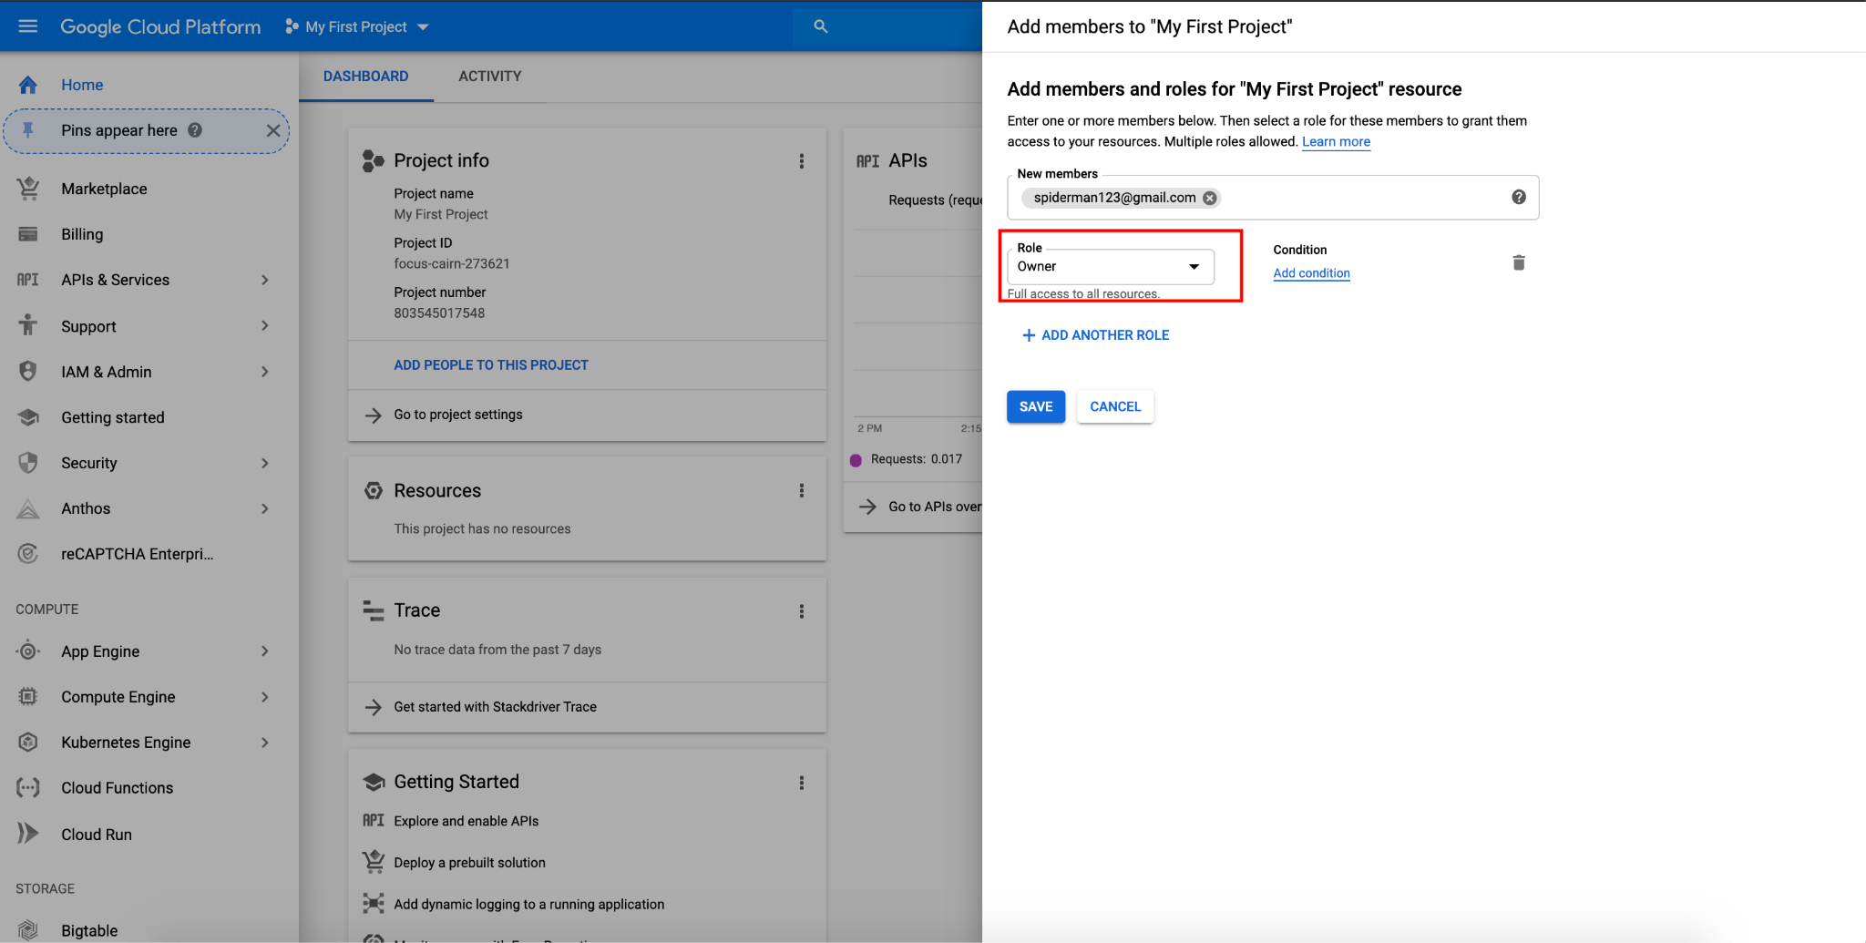
- Upgrade your account in order to use GPUs following this instruction. Otherwise Google Cloud Free Tier does not come with GPU support or quota.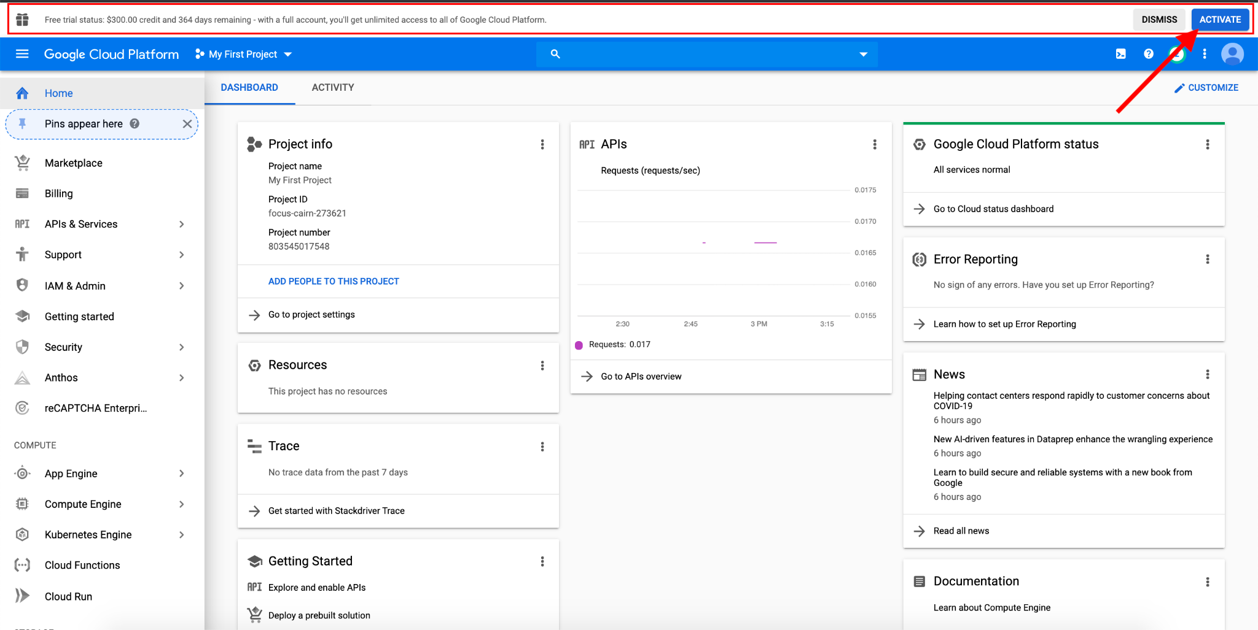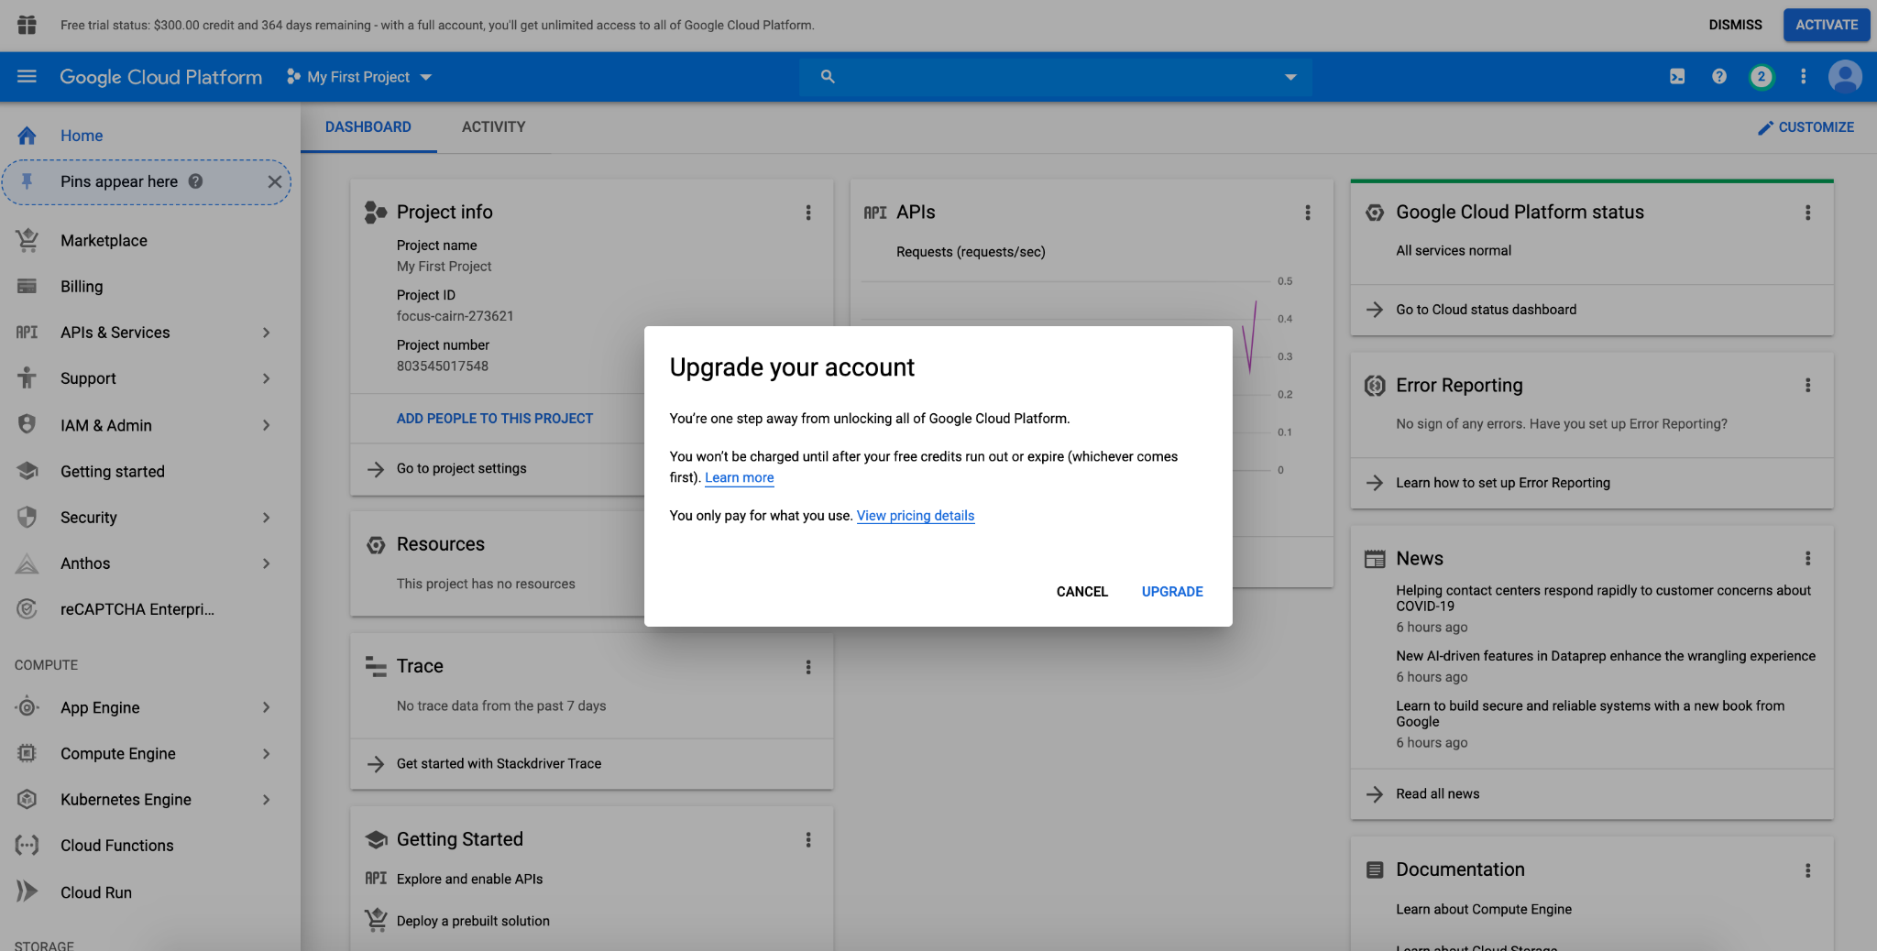

Claim CS224n GCP Credits
NOTE: You should have created and logged in your GCP account registered with your personal gmail account by now.
- We will release the link to claiming $50 GCP credits on Ed. After you complete the form, you will see a link to Google Cloud Education Grants page. It requires your Stanford email to receive the credits. (These credits can be applied to your GCP account registered with Personal GMail. )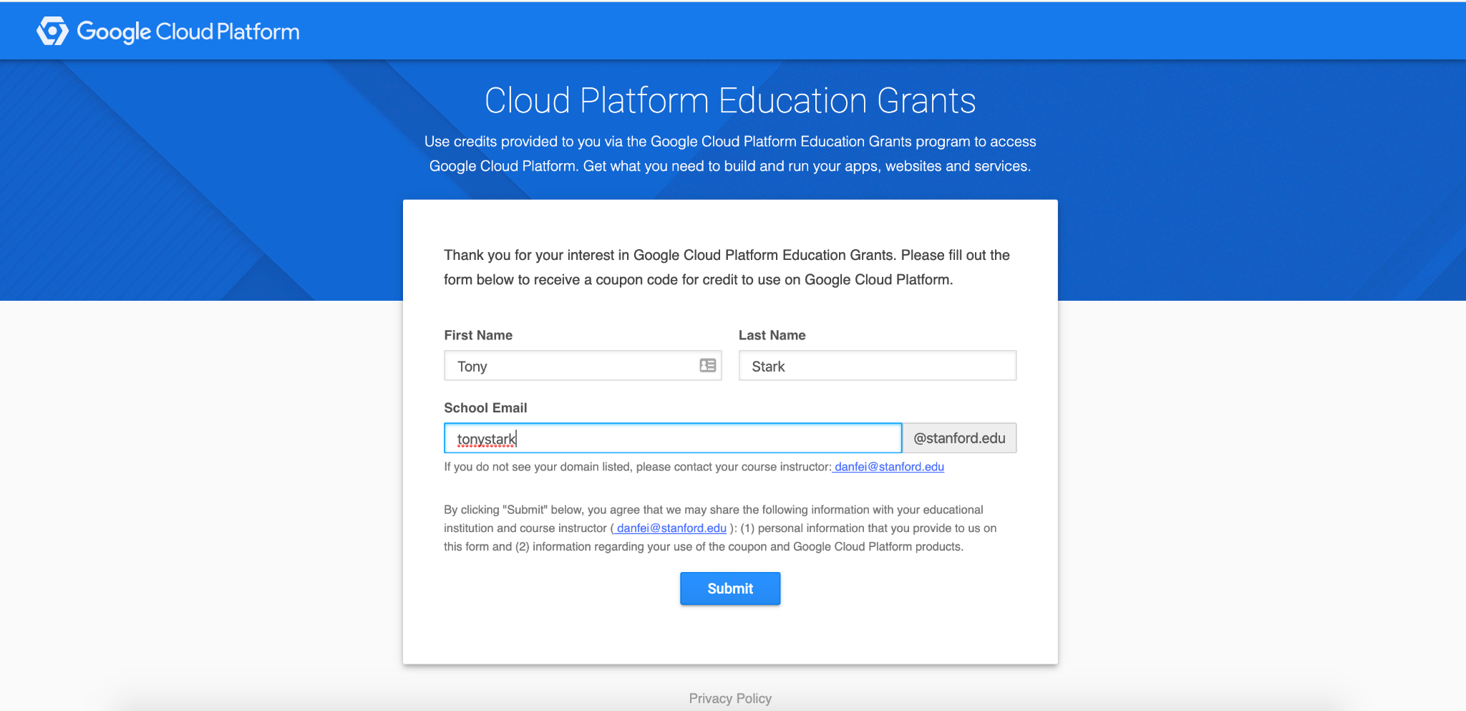
- After submission, you should receive an email from GCP with a link to confirm your email address. Click the link to verify your Stanford email.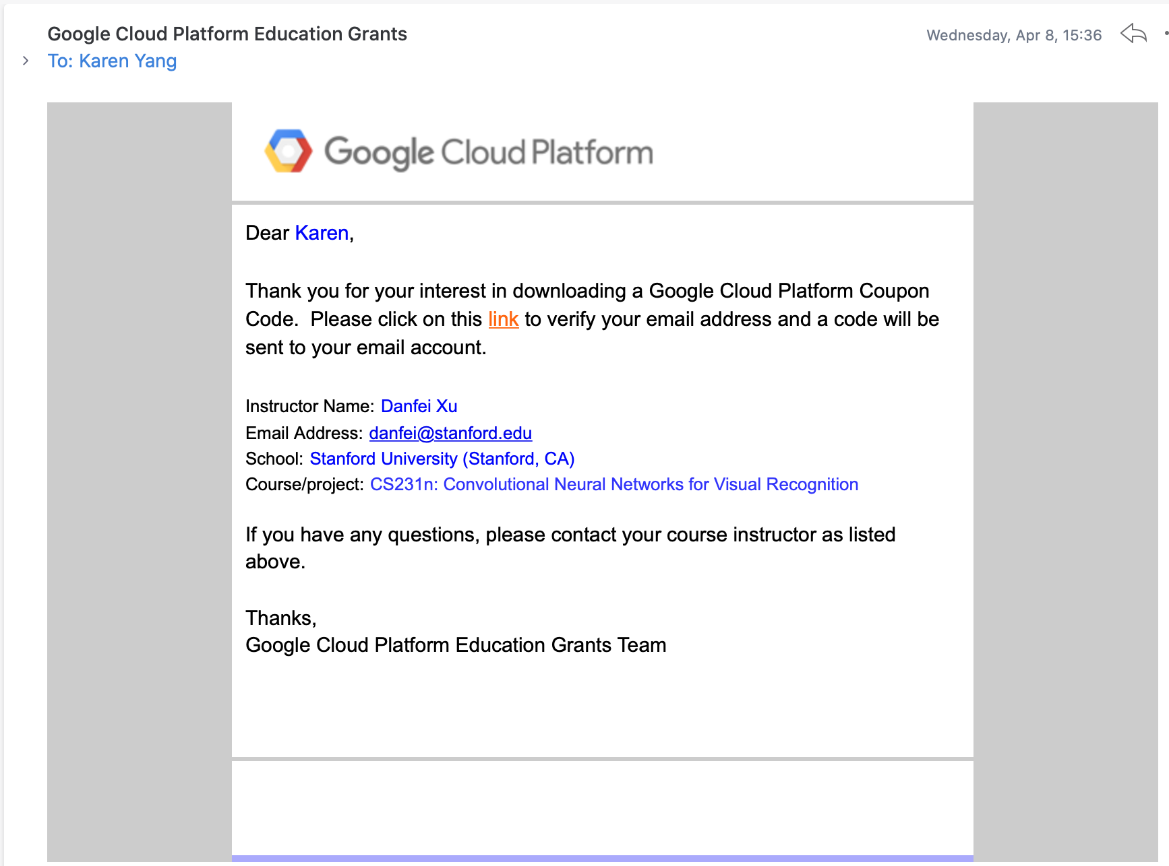
- You will soon receive another email from GCP with a link that applys the $50 credits to your account. After that the website will jump to your Billing page where you should see your have linked to CS224N billing account with $50 free credits.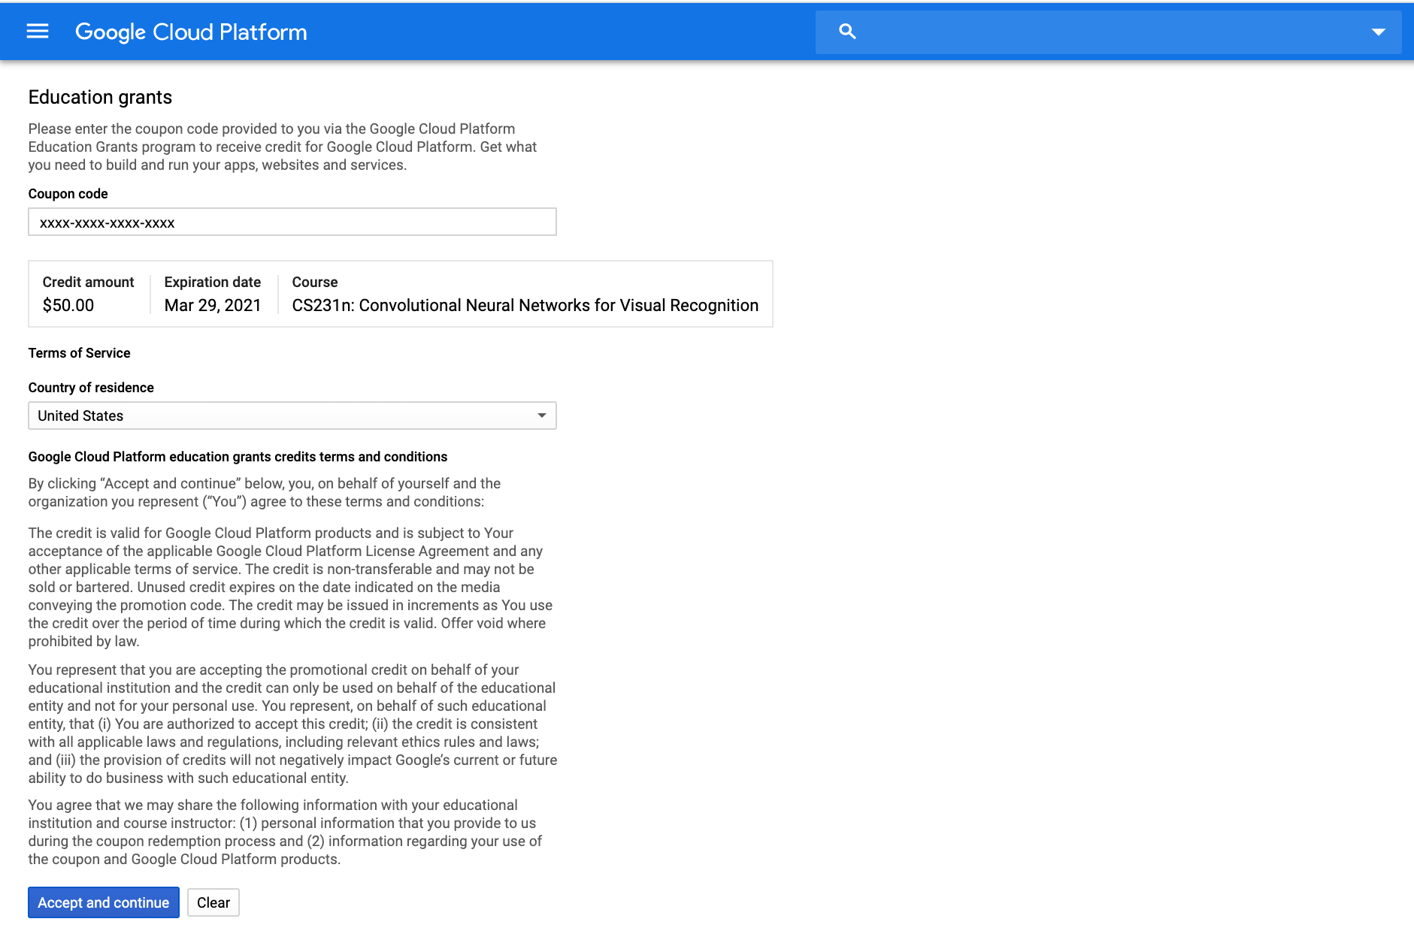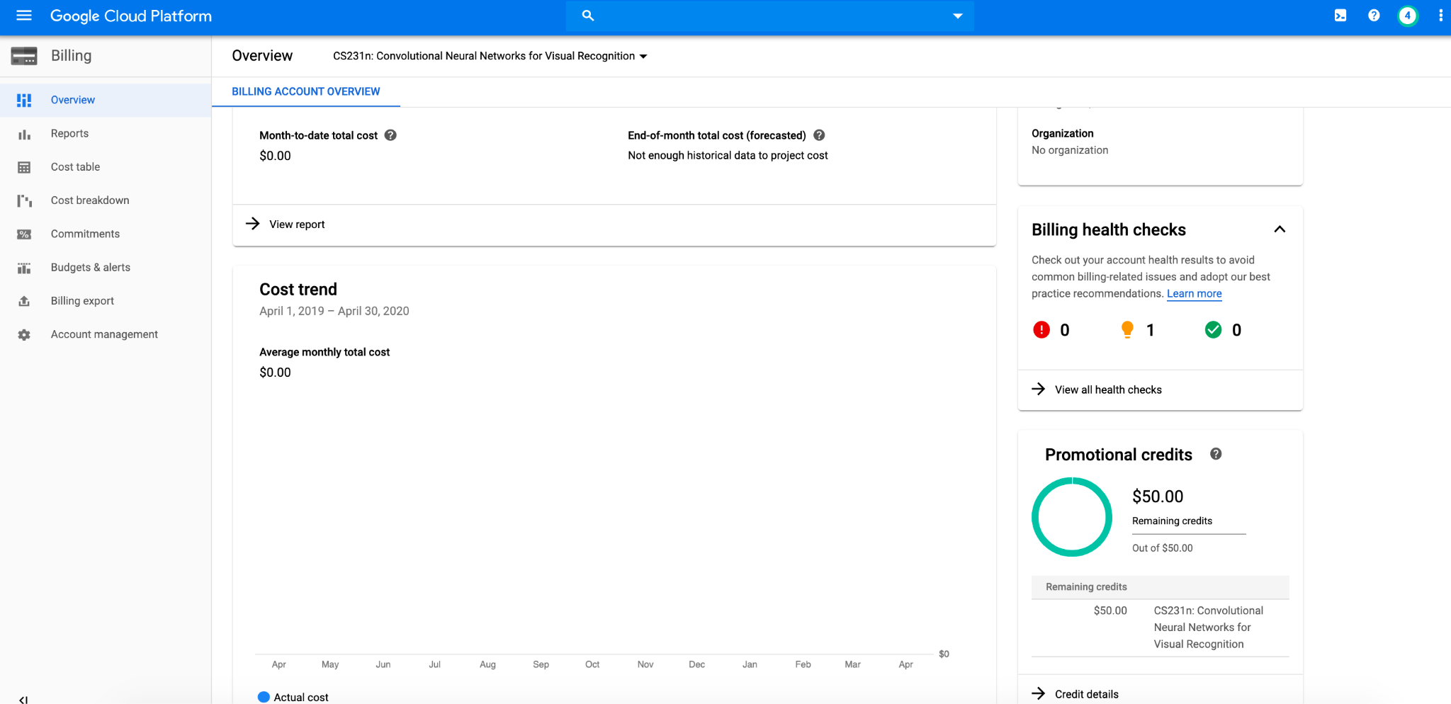
- Switching billing accounts from Free Tier credits to CS224N credits Google Cloud does not support combining credits. You will need to switch billing account if you want to use 2 sources of gcloud credits.

i.e. You can use up the $300 free credits first. Then switch to the CS224N billing account referring to this GCloud documentation.

Request an Increase in GPU Quota
Your account typically does not come with GPU quota. You have to explicitly request for it under IAM Admin > Quotas.

Please request the quota increase ASAP, because they will take up between couple minutes to a week to process! If you don't have GPU quota, you will have to create a CPU-only VM first and create another GPU VM later, explained in the next section.

You will need to change your quota for GPU (all regions).

- First, enable “Compute Engine API” if it’s not already enabled. You can do this by clicking on the hamburger () menu on the top right -> select “Compute Engine” -> click “Enable”. It may take a few minutes.
- Let’s now request GPU quota. On the Compute Engine page, click “Create Instance” on the top -> select “GPUs” under Machine Configuration section -> select “NVIDIA T4”. There will now be a box on the right side that you can click to request GPU quota. Once you do that, you can exit the create instances page.
- Now navigate to the quotas page directly. Select the GPU quota, click “Edit Quotas”, enter a new GPU limit of 1 along with description “CS224n class project”.

Alternate workflow:
- Select Limit name from the dropdown. Then select GPUs (all regions) from the next prompted dropdown. Click the checkbox for Global in the menu to the right, and click into ALL QUOTAS.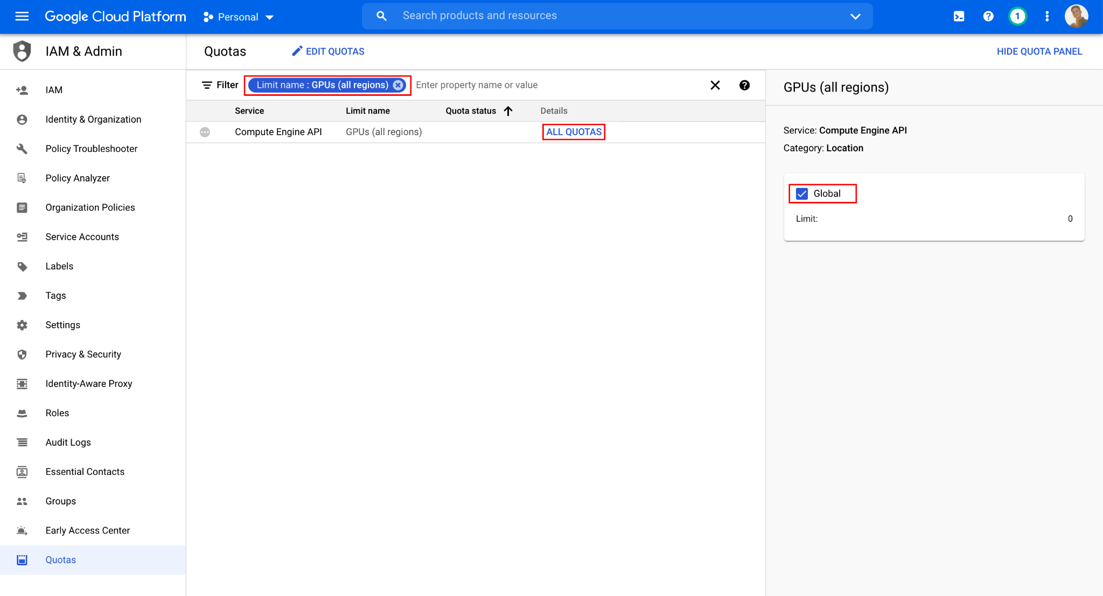
- Select the checkbox to the left of the first item in the table, and click EDIT QUOTAS. Set the New limit to 1, and make the Request description "Stanford CS 224N class project".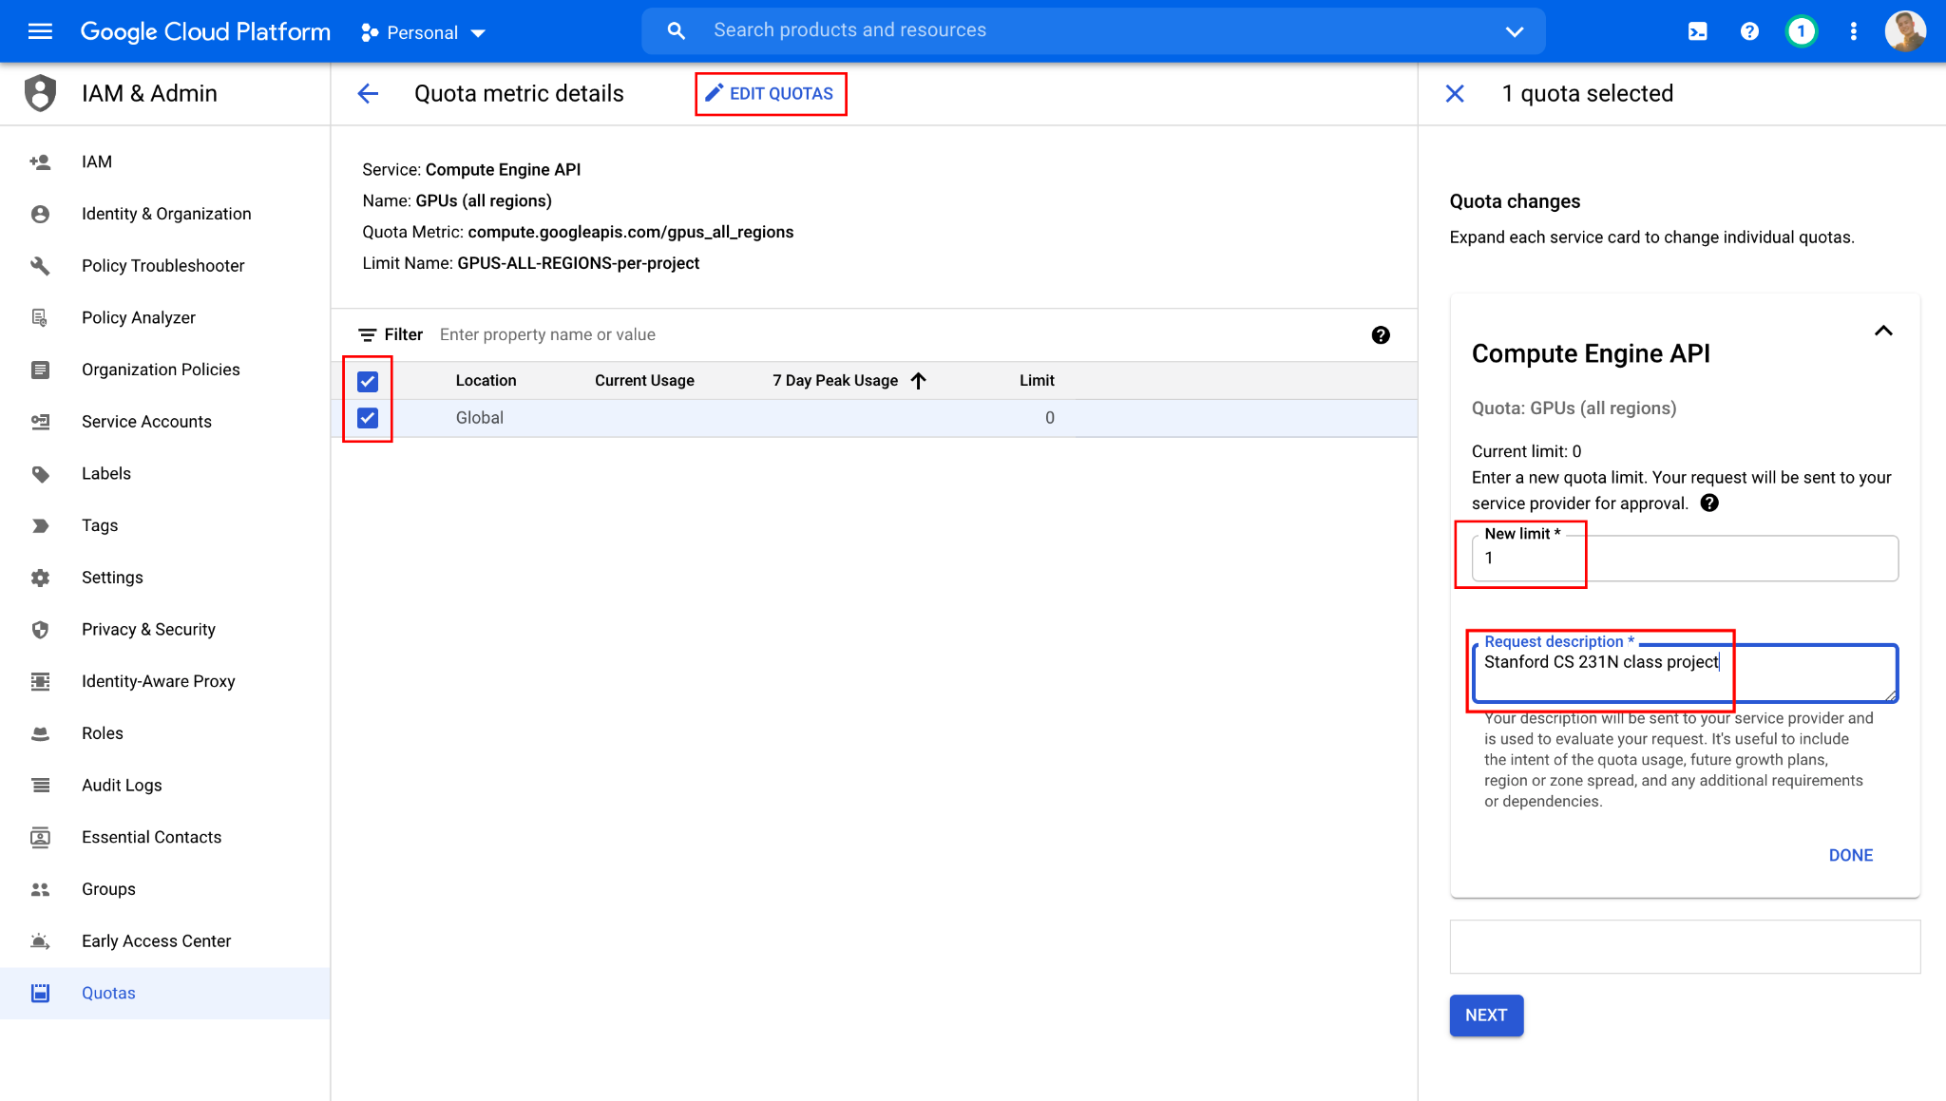
- Wait until GCP sends you a second email (first email is just to notify that they received the request) that looks like this. It could take a couple minutes to a couple days for them to approve.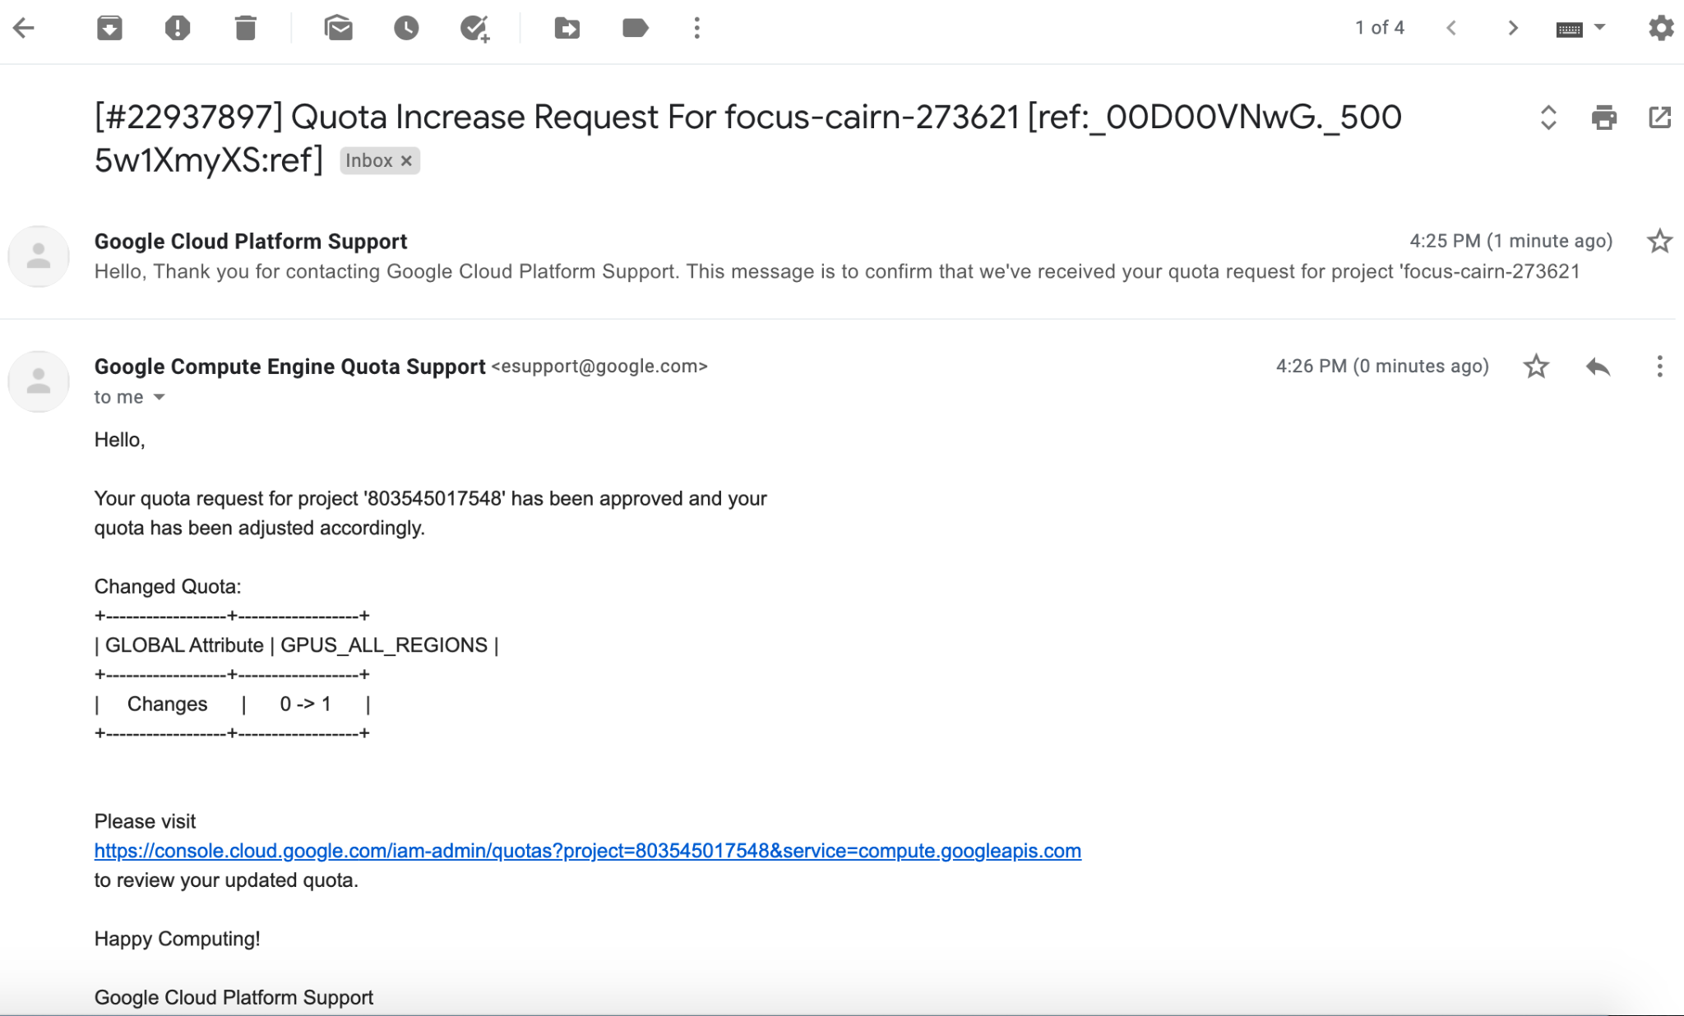

Why don't I See Any GPU-related Quota
- First, make sure you upgrade your free tier account to a full account following these instructions.
- If you just registered a Google Cloud account, GCP can be slow on setting up its Compute Engine API services (this is the service that provides GPU access, so the GPU quota won't show up before it is ready).

One way I found that can make Compute Engine API setup faster is by visiting the VM instance page by clicking Compute Engine > VM instances

If you see that Compute Engine is not ready yet, wait for a couple minutes until you see something like this screenshot below. The GPU-related Quota should now show up in IAM Admin > Quotas.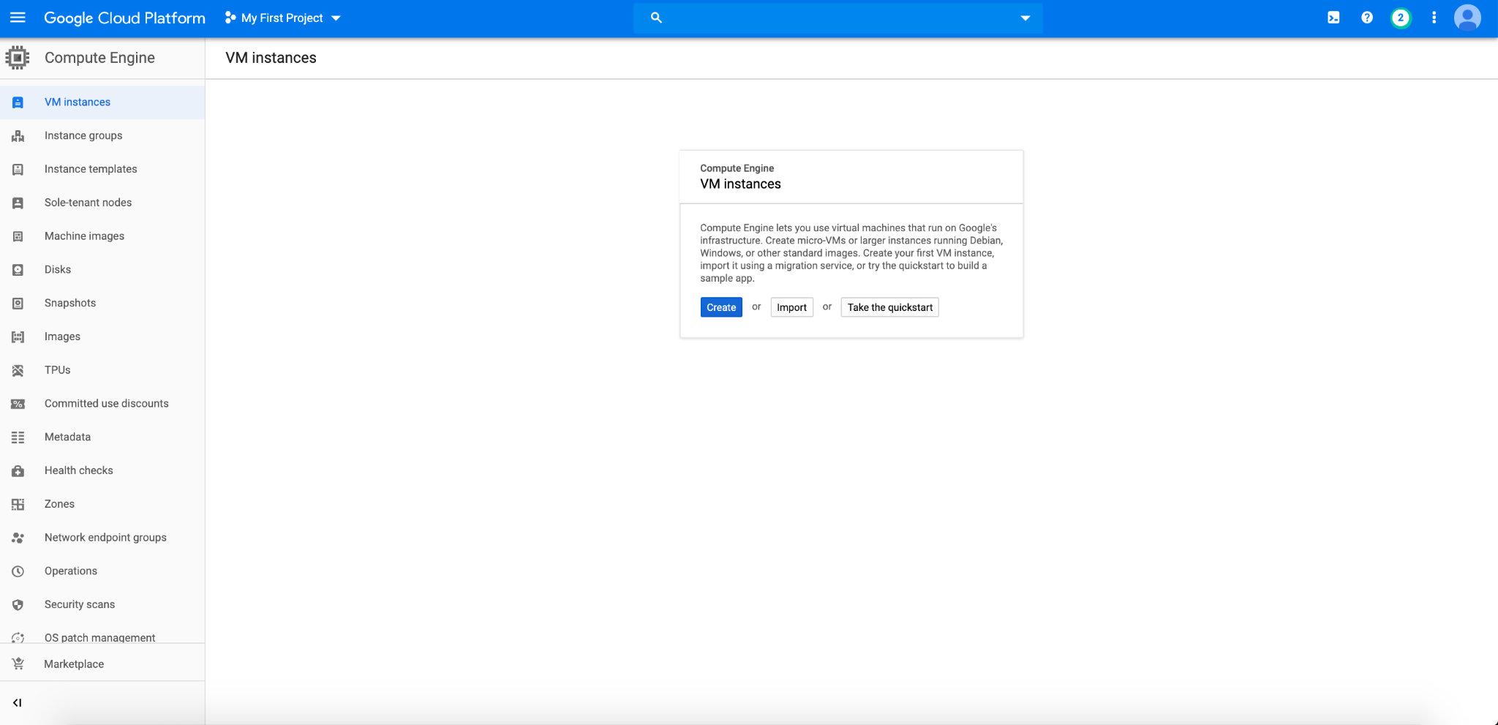

- For region-specific GPUs: Check that you have a default zone and region set under Compute Engine > Settings > Region / Zone. Some zones do not have certain GPU resources. Check pricing and spec for GCP GPUs to find the availability of GPU resources.

More instructions at General quota instructions and Step-by-step GPU-specific walk-through (all answers in the link are useful)

Set Up Google Cloud VM Image

Customize VM Hardware
- Go to this gcloud marketplace. You may (or may not) be taken to a page where you have to click on "Launch", and then you should see a configuration sheet with the title "New Deep Learning VM deployment".
- Fill in Deployment name field with your preferred VM name.
- For Zone, pick one of the zones from this list that supports your desired GPU type (eg T4): If when deploying you get a ZONE_RESOURCE_POOL_EXHAUSTED error, then try again with another zone until it works.
- In Machine type box, click GPUs.
- For GPU type, NVIDIA T4 is typically enough. P100 and V100 are way more expensive (check the price on the right), but also faster and has larger memory. Check pricing and spec for GCP GPUs. GPU drivers and CUDA will be automatically installed only if you select at least 1 GPU.
- Choose your desired number of CPUs and memory (if you are unsure, keep the default).
- In Frameworks field, choose the most recent version of TensorFlow or PyTorch, depending on which framework you plan to use.
- Check the box Install NVIDIA GPU driver automatically on first startup?.
- Check the box Enable access to JupyterLab via URL instead of SSH. (Beta).
- Leave all other options as default.
- Click the blue button Deploy at the end of the page. It will automatically start your instance, so if you don't need to use it now, stop it immediately.

Your configuration sheet should look similar to the image below. Follow exactly the same configuration for the ones with red boxes. For configurations with orange boxes, you can adjust it based on your project need as discussed below.

Pay attention to the monthly price, make sure you claim only necessary HW resources, so that you can use your GCP instance for longer. Once you run out of credits, the VM instance will be shut down automatically and you might lose unsaved data and models. If you are almost running out of credits, contact the course staff.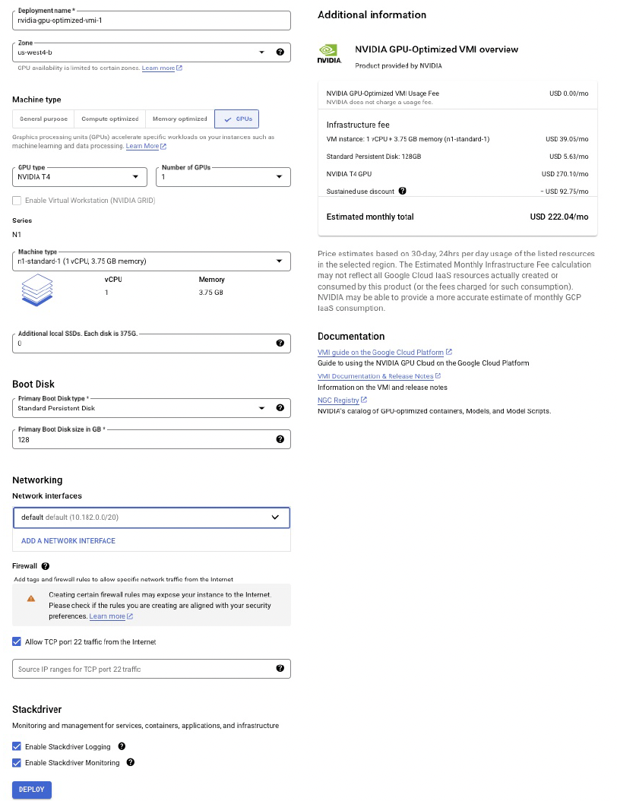

Change Configuration on Already Created VM Instances
- You can always change the number of CPUs, number of GPUs, CPU memory, and GPU type after your VM has been created.
- Just stop your instance, go to your VM instance's details at Compute Engine > VM instances > [click on instance name].
- Click "edit" on your VM's page to modify the settings. Finally click "Save".

Getting a Static IP Address
If you want to have a static IP for ease of access, you can change the External IP address of your Google Cloud Engine instance to be static (see screenshot below).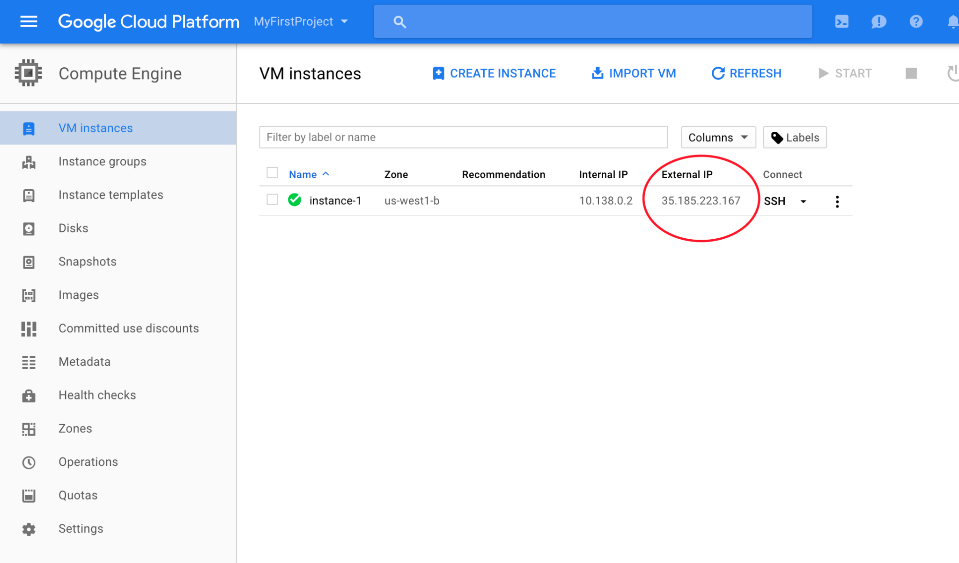
To Do this, click on the 3 line icon next to the Google Cloud Platform button on the top left corner of your screen, go to VPC network > External IP addresses (see screenshot below).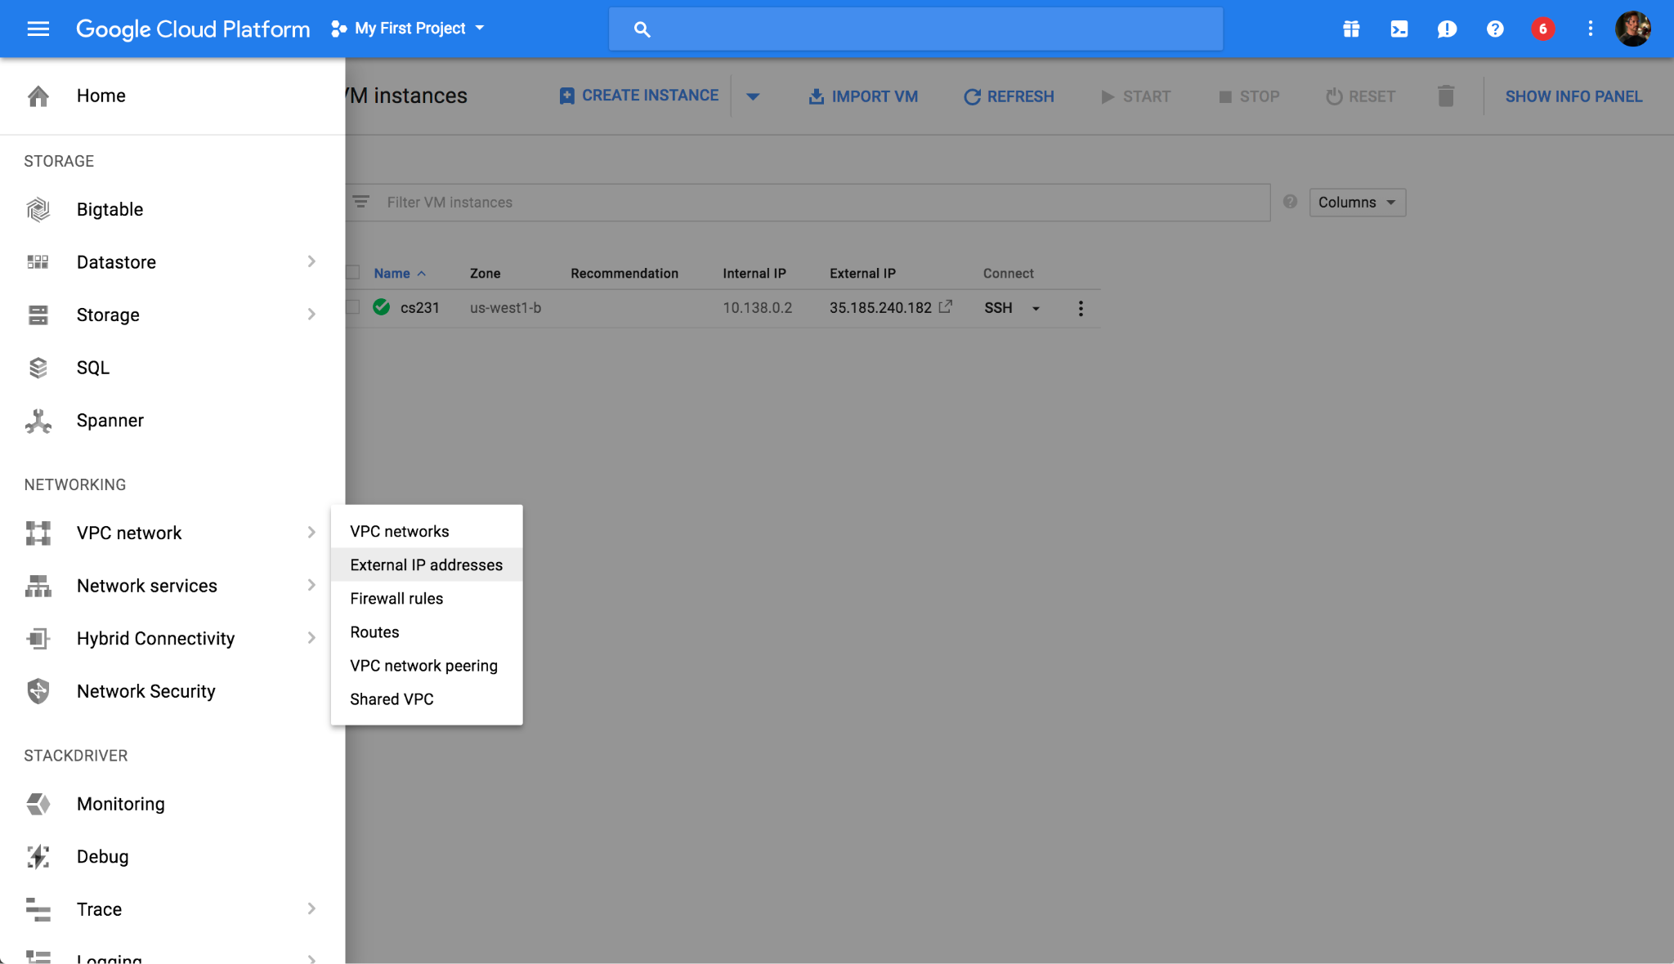
To have a static IP address, change Type from Ephemeral to Static. Enter your preferred name for your static IP, ours is cs224n-ip (see screenshot below). And click on Reserve.

NOTE: At the end of CS 224N when you don't need your instance anymore, release the static IP address because Google charges a small fee for unused static IPs (according to this page).

Take note of your Static IP address (circled on the screenshot below). We use 35.185.240.182 for this tutorial.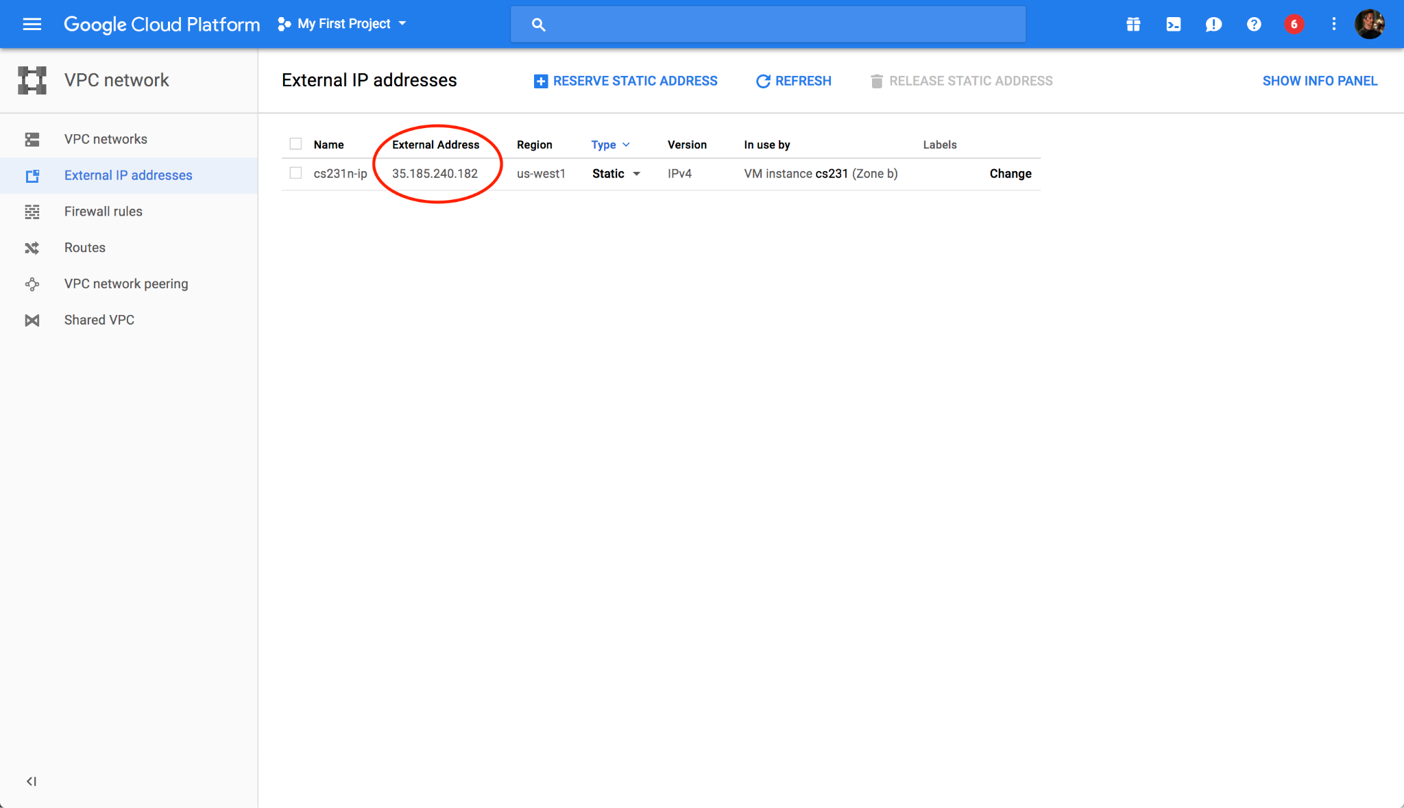

Access Your Newly Created VM
Now that you have created your virtual GCE, you want to be able to connect to it from your computer. The rest of this tutorial goes over how to do that using the command line.

Install gcloud command-line Tools
To access gcloud commands in your local terminal, install Google Cloud SDK that is appropriate for your platform and follow their instructions.

If gcloud command is not in your system path after installation, you can also reference it by its full path /<DIRECTORY-WHERE-GOOGLE-CLOUD-IS-INSTALLED>/bin/gcloud. See this page for more detailed instructions.

To ssh into your VM, go to your VM instance details page by clicking on its name. Start the VM instance first. Once it has a green check mark on, click on the drop-down arrow and select View gcloud command instead to retrieve the terminal command. It should look like

gcloud compute --project "<YOUR_PROJECT_ID>" ssh --zone "us-west1-b" "<YOUR_VM_NAME>"

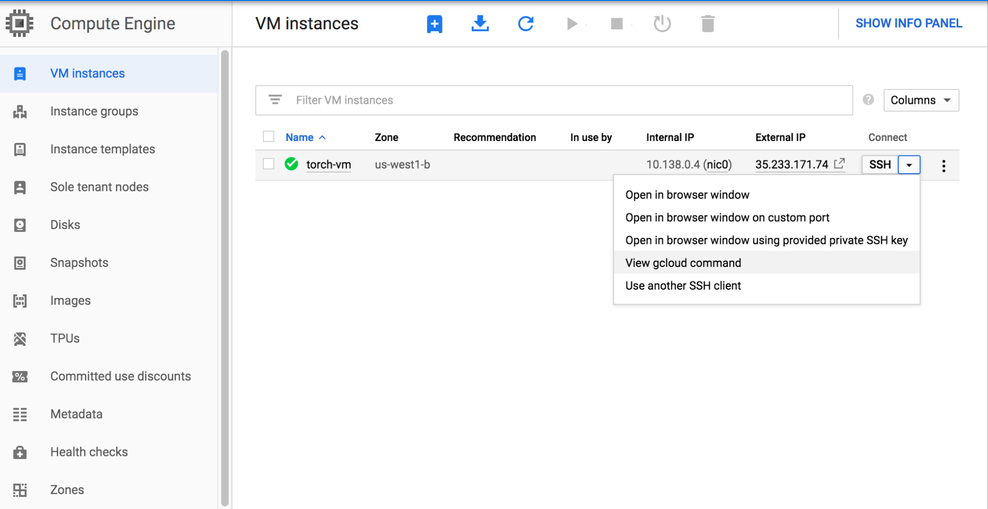
You should now be able to run nvidia-smi and see the list of attached GPUs and their usage statistics. Run watch nvidia-smi to monitor your GPU usage in real time.

Remote Server Development

Transferring Files From Your Instance To Your Computer
For instance, to transfer file.zip from GCE instance to your local laptop. There is an easy command for this purpose:
gcloud compute scp <user>@<instance-name>:/path/to/file.zip /local/path

For example, to download files from our instance to the current folder:
gcloud compute scp tonystark@cs224n:/home/shared/file.zip .

The transfer works in both directions. To upload a file to your instance:
gcloud compute scp /my/local/file tonystark@cs224n:/home/shared/

If you would like to transfer an entire folder, you will need to add a recursive flag:
gcloud compute scp --recurse /my/local/folder tonystark@cs224n:/home/shared/

Other Tips
You can use Tmux to keep the training sessions running when you close your laptop. Also, if your collaborators log into the same account on the VM instance, they will see the same tmux session screen in real time.

You can develop your code on a remote server directly if you are comfortable with vim or emac.

You can develop locally on your favorite editor, push to your branch on Github, and pull on a remote server to run. (git commit frequently is also one of good Github practices)

Besides gcloud compute scp, another tool you can check out is rsync which can synchronize files and folders between your local machine and remote server.

BIG REMINDER: Make sure you stop your instances!
Don't forget to stop your instance when you are done (by clicking on the stop button at the top of the page showing your instances). You can restart your instance and the downloaded software will still be available.

We have seen students who left their instances running for many days and ran out of credits. You will be charged per hour when your instance is running. This includes code development time. We encourage you to read up on Google Cloud, regularly keep track of your credits and not solely rely on our tutorials.

